Document description:
This document is a pre-lab report for the Lab Assignment #1.

Table of contents:

1. Introduction 1
2. Funcional Behavioral Requirements 2
3. Design of Controller Components 2
4. Simulation Testing Plan 2
5. Prototype Testing Plan 2
6. Conclusion 2

1. Introduction

In this lab assignment, students will take their first pass through a complete structured development process, although for a very simple project involving only a small number of logic gates. Students are given a simple description of the customer’s needs, and then at home they systematically go through the design process of translating those needs into detailed requirements, a system design, and a detailed design in an organized way. They test their design in simulation at home, and then test their designs in lab on the actual boards. In later projects, they will go through this process again for larger projects.
-- quoted from Lab Assignment #1 document.

2. Functional Behavioral Requirements

System-level functional requirement1: Whenever the motion sensor reports the room is empty, power to all lights as well as to the projector should be turned off, to save energy, no matter what the state of the wall switches is.

System-level functional requirement2: Otherwise (whenever the room is not empty),
a. The main (middle & back) room lights should be on if and only if the switch by the door is in the up position.
b. The projector should have power if and only if the “projector” switch on the back panel near the lectern is in the up position. c. The bright front room lights should be on if and only if the switch by the door is in the up position, and the “front lights” switch by the lectern in not in the down position

3. Design of Controller Components

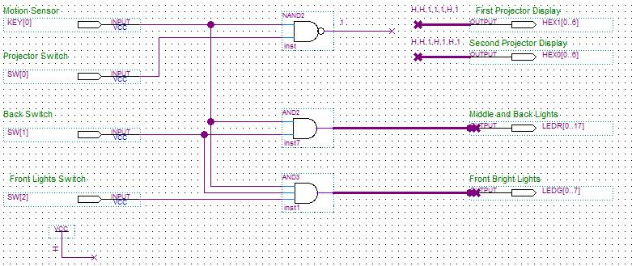

The schematic above illustrates the design for the assigned logic.

4. Simulation testing plan
With the use of Quartus and the “Simulator Tool” we can make sure the outputs are what we expect. The steps include creating input waveforms for the input nodes, starting the simulation, viewing the report, comparing waveforms with output waveforms, and lastly making sure the delay is non due to functional simulation.

5. Prototype testing plan

During the lab, to systematically test all of the design functional requirements I will take the following steps:
Step1: Make sure the program is compiled correctly.
Step2: Test each switch (All 3) and situation.

8. Conclusion

The purpose of this lab is to design a logic circuit to control power to room lights and ceiling projector in a room with a motion sensor to provide an automatic power-off feature. Analyzing and preparing for this lab it gave me a better understanding of basic logic gates. Also, this lab provided practice in figuring out how to manipulate both active-low and active-high signals in a single design. This was also the first lab in which logic gate were used in Quartus to create simple circuits. Something substantially different in this lab is the use of test vectors and simulations in Quartus; this allows a broader range of examination.

